Test Case: tc006_SPX_Dev5_Crear_Requisicion_Spot_Tipo_Cobro_Proyect_Urgent
Step 1 - Enter username and password and click to button Enter: Credentials Entered
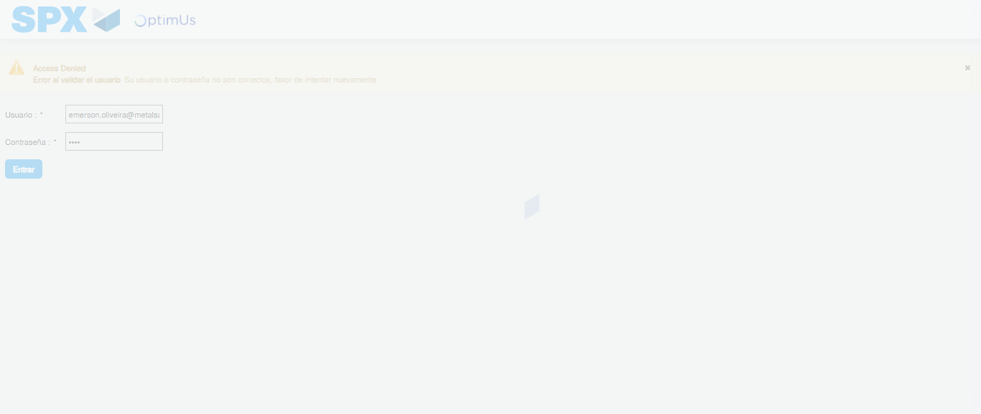Image file-name: QC_Testing-tc006_SPX_Dev5_Crear_Requisicion_Spot_Tipo_Cobro_Proyect_Urgent-1787009115399

Step 2 - Select to UEN and Access to Spot Buy Requisitions : UEN Correctly selected and Correct access
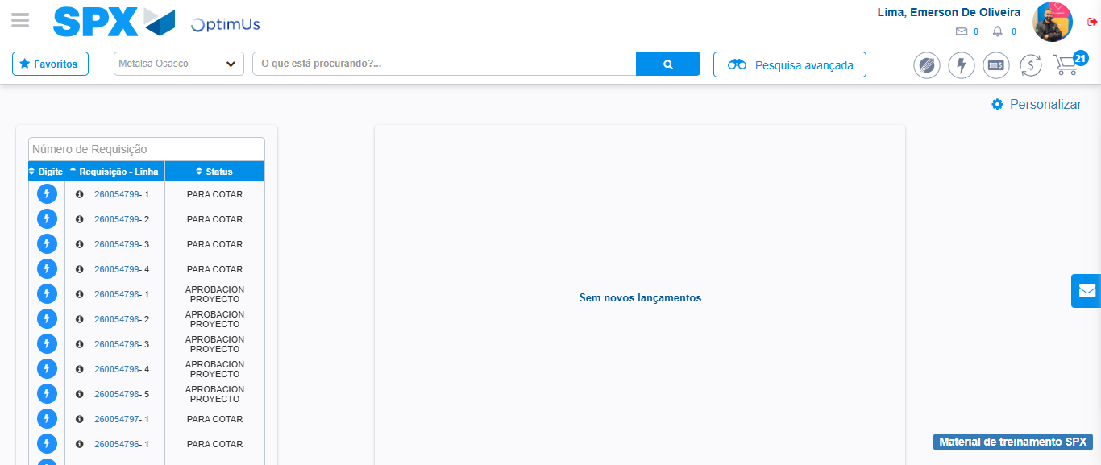Image file-name: QC_Testing-tc006_SPX_Dev5_Crear_Requisicion_Spot_Tipo_Cobro_Proyect_Urgent-1787009200003

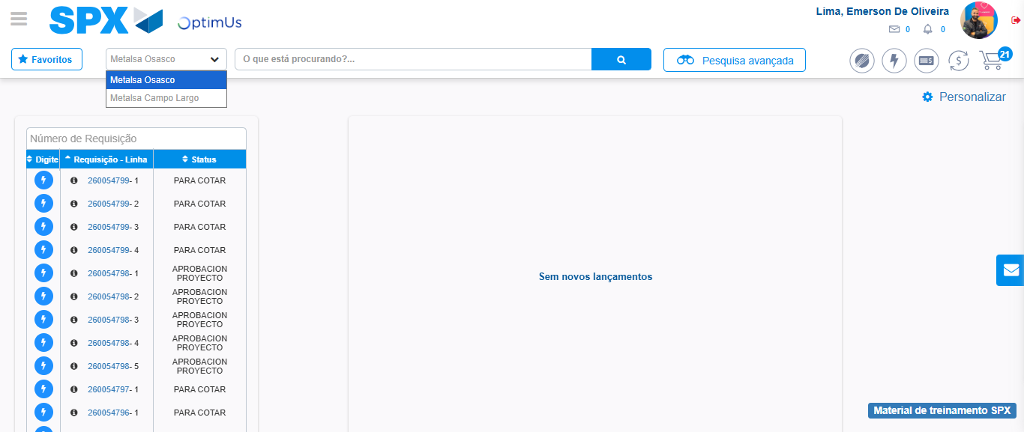Image file-name: QC_Testing-tc006_SPX_Dev5_Crear_Requisicion_Spot_Tipo_Cobro_Proyect_Urgent-1787009202651

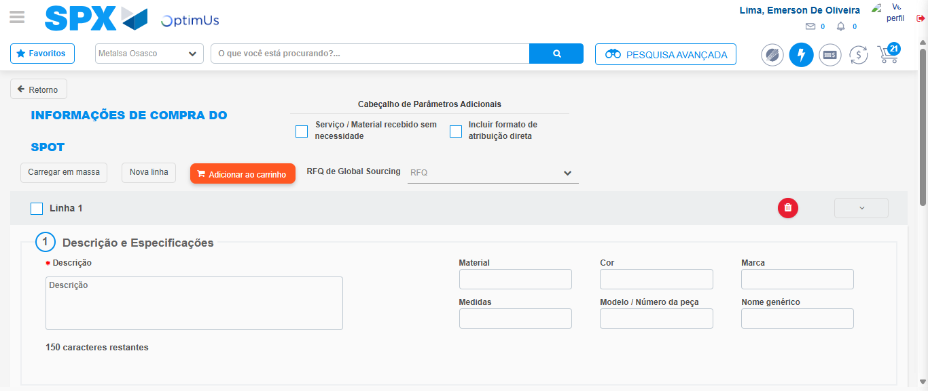Image file-name: QC_Testing-tc006_SPX_Dev5_Crear_Requisicion_Spot_Tipo_Cobro_Proyect_Urgent-1787009215264

Step 3 - Data Capture Spot Buy Requisition: Data captured correctly
Image file-name: QC_Testing-tc006_SPX_Dev5_Crear_Requisicion_Spot_Tipo_Cobro_Proyect_Urgent-1787009215581

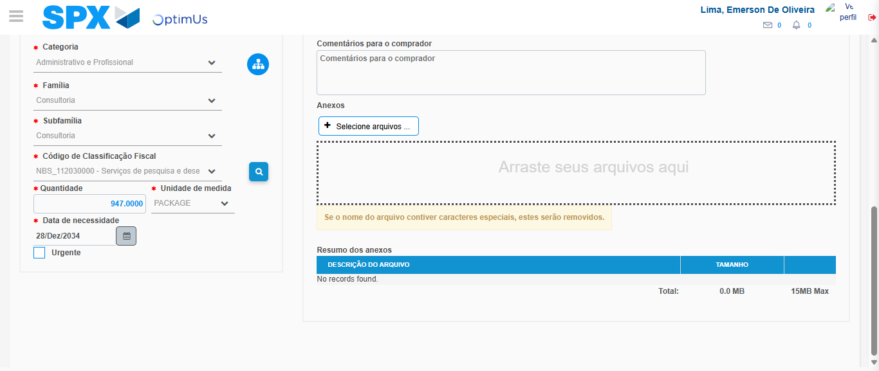Image file-name: QC_Testing-tc006_SPX_Dev5_Crear_Requisicion_Spot_Tipo_Cobro_Proyect_Urgent-1787009232453

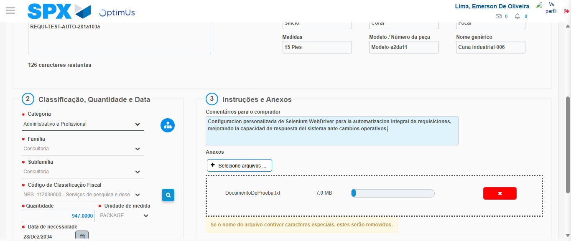Image file-name: QC_Testing-tc006_SPX_Dev5_Crear_Requisicion_Spot_Tipo_Cobro_Proyect_Urgent-1787009233370

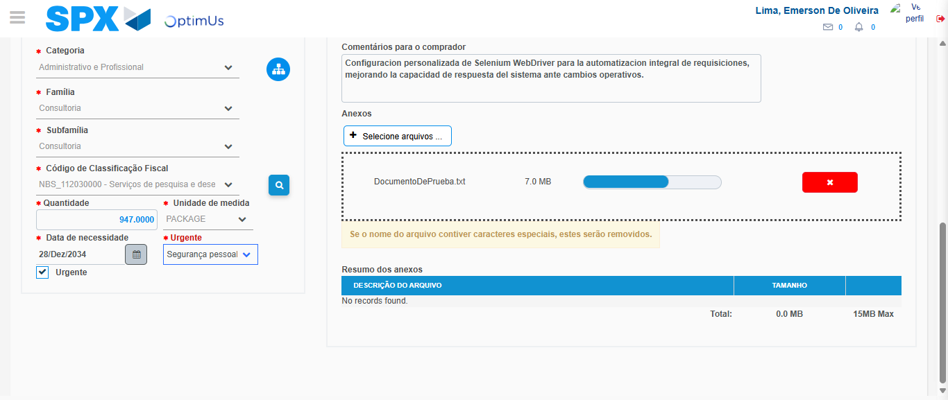Image file-name: QC_Testing-tc006_SPX_Dev5_Crear_Requisicion_Spot_Tipo_Cobro_Proyect_Urgent-1787009237237

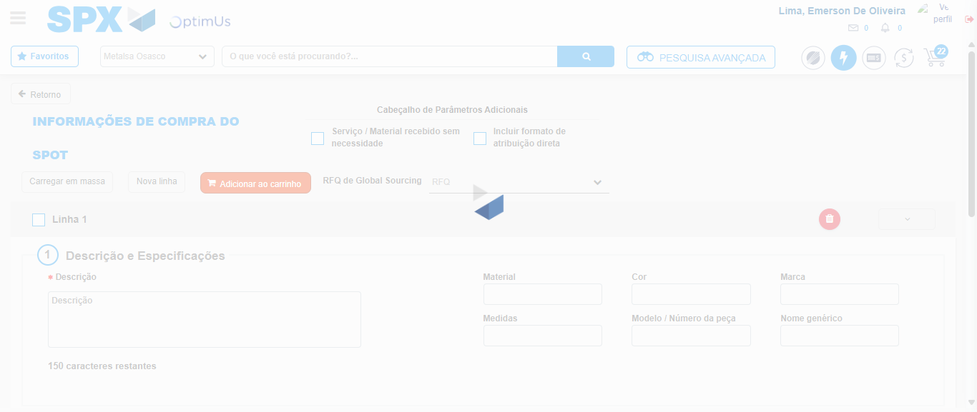Image file-name: QC_Testing-tc006_SPX_Dev5_Crear_Requisicion_Spot_Tipo_Cobro_Proyect_Urgent-1787009248561

Step 7 - Return to Main Page SPX : Return to Main Page SPX
Image file-name: QC_Testing-tc006_SPX_Dev5_Crear_Requisicion_Spot_Tipo_Cobro_Proyect_Urgent-1787009200003

Image file-name: QC_Testing-tc006_SPX_Dev5_Crear_Requisicion_Spot_Tipo_Cobro_Proyect_Urgent-1787009202651

Image file-name: QC_Testing-tc006_SPX_Dev5_Crear_Requisicion_Spot_Tipo_Cobro_Proyect_Urgent-1787009215264

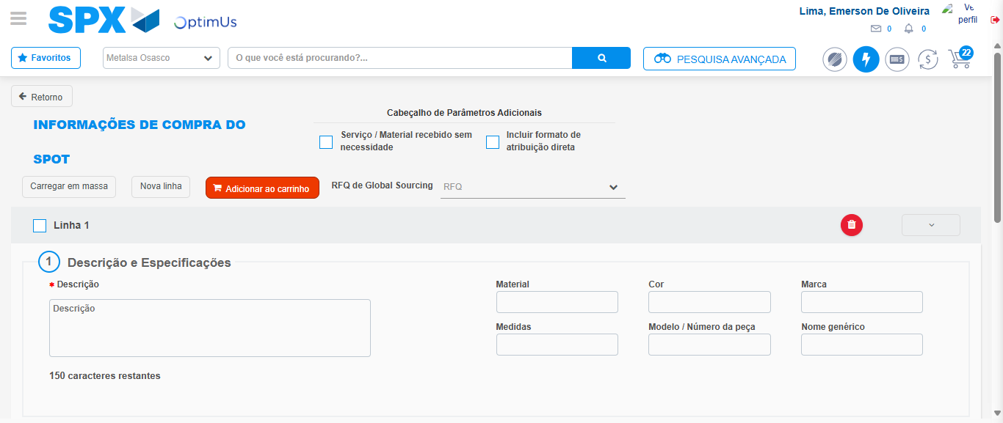Image file-name: QC_Testing-tc006_SPX_Dev5_Crear_Requisicion_Spot_Tipo_Cobro_Proyect_Urgent-1787009250874

Image file-name: QC_Testing-tc006_SPX_Dev5_Crear_Requisicion_Spot_Tipo_Cobro_Proyect_Urgent-1787009251087

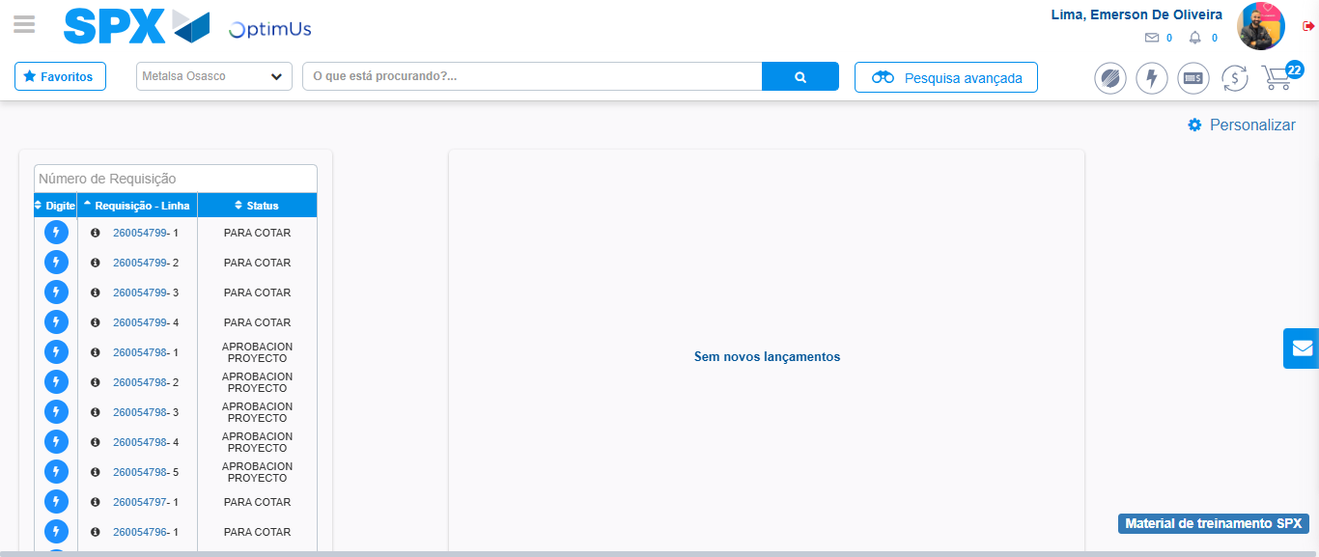Image file-name: QC_Testing-tc006_SPX_Dev5_Crear_Requisicion_Spot_Tipo_Cobro_Proyect_Urgent-1787009272218

Step 8 - Log Out : Log Out SPX
Image file-name: QC_Testing-tc006_SPX_Dev5_Crear_Requisicion_Spot_Tipo_Cobro_Proyect_Urgent-1787009272465

